E-Learning

Vishal Kumar Singh  
*dept. of computer science and Engineering   
(of Affiliation)*  
Chandigarh University *(of Affiliation)*Punjab, India  
21bcs2439@cuchd.in

Sumit Saini  
*dept. of computer science and Engineering   
(of Affiliation)*  
Chandigarh University *(of Affiliation)*Punjab, India  
21bcs11504@cuchd.in Sumit Anand  
*dept. of computer science and Engineering   
(of Affiliation)*  
Chandigarh University *(of Affiliation)*Punjab, India  
21bcs11540@cuchd.in

Sanjana Rathore  
*dept. of computer science and Engineering   
(of Affiliation)*  
Chandigarh University *(of Affiliation)*Punjab, India  
21bcs11612@cuchd.in Muktanshi Sharma   
*dept. of computer science and Engineering   
(of Affiliation)*  
Chandigarh University *(of Affiliation)*Punjab, India  
21bcs11545@cuchd.in

*Abstract*— **The e-learning website is a platform that provides a virtual learning environment for users to access a variety of educational materials and courses. It utilizes technology to facilitate the learning process, enabling users to learn at their own pace and from anywhere in the world.**

Keywords—Learning, Internet, Literature, Survey, Success.

# Introduction

E-learning websites have the potential to address various challenges faced in traditional classroom instruction while providing numerous benefits to learners. Limited accessibility to quality education due to geographical barriers or lack of resources can be overcome through e-learning, as it breaks the boundaries of physical classrooms and allows learners to access educational content from anywhere in the world. The flexibility of online courses enables students to study at their own pace and convenience, eliminating the constraint of fixed schedules. Additionally, e-learning platforms offer a wide range of courses and learning materials, allowing learners to pursue their interests and passions. Although online learning may lack the same level of social interaction as traditional classrooms, it provides opportunities for global connectivity and collaboration, fostering group discussions and knowledge sharing among learners from different backgrounds. Quality control can be addressed through rigorous course evaluation and accreditation processes. However, it is essential for e-learning platforms to ensure strong online security measures to protect user data and maintain user trust. Despite certain challenges, e-learning websites continue to revolutionize education by providing accessible, flexible, and engaging learning experiences for students worldwide.[1]

# SYSTEM OVERVIEW

The e-learning website system is designed to provide users with a comprehensive online learning experience. It begins with user registration and authentication, allowing individuals to create accounts using their personal information or by linking their social media accounts. The platform offers a robust course management system where administrators can create and manage various courses, incorporating multimedia resources such as video lectures, quizzes, assignments, and more. Users access their personalized dashboards upon login, providing an overview of enrolled courses, progress tracking, and upcoming deadlines. The platform also facilitates communication and collaboration among learners and instructors through features like discussion forums, live chat, and video conferencing. To ensure quality and effectiveness, the system generates performance analytics and reports, enabling administrators and instructors to evaluate course performance and make informed decisions. Payment and subscription management features are included for paid courses or subscriptions. Security and privacy are prioritized with encryption, secure authentication, and regular audits. Overall, the e-learning website system aims to deliver an accessible, engaging, and secure learning environment for users, providing them with valuable educational resources and fostering interactive learning experiences.

# SCOPE OF E-LEARNING

The scope of an e-learning website encompasses a wide range of possibilities and opportunities. It includes providing learners with access to diverse educational content and resources, allowing them to expand their knowledge and skills in various subjects. The scope extends to different types of courses, such as academic subjects, professional development, language learning, and personal growth. E-learning websites can cater to learners of all ages, from children to adults, and offer both free and paid courses to accommodate different needs and budgets. The scope also involves incorporating interactive features like quizzes, assignments, and assessments to enhance the learning experience and track progress. Collaboration and communication tools enable learners to engage with instructors and peers, promoting an interactive learning community. Additionally, the scope encompasses the integration of emerging technologies, such as virtual reality or artificial intelligence, to provide innovative and immersive learning experiences. Overall, the scope of an e-learning website is vast, aiming to provide accessible, flexible, and engaging educational opportunities for learners worldwide.

# CONTROLL DESIGN

Control design in the context of an e-learning website involves designing and implementing mechanisms to manage and regulate the system's operations effectively. This includes developing user-friendly interfaces, intuitive navigation menus, and clear instructions for users. Control design also encompasses implementing access controls and security measures to protect user data and ensure compliance with privacy regulations. Furthermore, it involves monitoring and managing user interactions, course enrollments, progress tracking, and performance analytics to ensure a seamless learning experience for users and efficient administration of the e-learning platform.

# LITERATURE REVEW

A literature review on e-learning websites reveals several key themes and findings related to their effectiveness, impact, and challenges. Studies have shown that e-learning platforms offer flexibility and convenience, allowing learners to access educational resources anytime and anywhere. Research indicates that e-learning can enhance learner engagement, motivation, and knowledge retention compared to traditional classroom instruction. Additionally, e-learning websites provide a wide range of multimedia resources, including video lectures, interactive quizzes, and online forums, facilitating interactive and collaborative learning experiences. Learners can benefit from personalized learning paths and tailored content that cater to their individual needs and interests. However, challenges associated with e-learning platforms have also been identified. Technical difficulties, such as poor internet connectivity and system glitches, can hinder the learning experience and frustrate users. Quality control is another concern, as the proliferation of e-learning websites makes it challenging to distinguish between high-quality and low-quality courses. Security and privacy issues have also been raised, highlighting the need for robust measures to protect user data and ensure confidentiality. Overall, the literature suggests that e-learning websites have the potential to revolutionize education by providing accessible, flexible, and engaging learning opportunities. However, addressing challenges related to technical issues, quality control, and security is crucial to ensure the efficacy and trustworthiness of e-learning platforms.[2] Further research is needed to explore the long-term effects of e-learning on learner outcomes and to develop best practices for designing and implementing effective e-learning websites.

The theory and practice of e-learning involve the application of educational principles and pedagogical strategies in the context of online learning environments. From a theoretical perspective, e-learning draws upon various educational theories and frameworks to guide the design and delivery of online courses. One such theory is the constructivist approach, which emphasizes learner-centeredness and active engagement.[3] In e-learning, this theory can be applied by encouraging learners to construct their knowledge through interactive activities, collaborative discussions, and problem-solving tasks. Another prominent theory in e-learning is the cognitive load theory, which explores how learners process information and manage their cognitive resources. It suggests that effective e-learning design should minimize extraneous cognitive load (such as irrelevant information) and optimize intrinsic cognitive load (essential learning materials) to facilitate learning. Applying this theory, e-learning designers strive to present information in a clear and organized manner, utilize multimedia resources effectively, and provide scaffolding to support learners' comprehension and retention. Additionally, the theory of online community of inquiry highlights the importance of social presence, cognitive presence, and teaching presence in online learning environments. It emphasizes the need for interactions and collaboration among learners and instructors to create meaningful learning experiences. E-learning platforms incorporate features like discussion forums, group projects, and live chat sessions to foster social and cognitive presence. Moreover, the theory of self-regulated learning is highly relevant in e-learning. It emphasizes learners' ability to set goals, monitor their progress, and employ strategies to achieve learning outcomes. E-learning environments provide opportunities for learners to plan their learning, track their progress, reflect on their performance, and adjust their strategies accordingly. In terms of practical implementation, the practice of e-learning involves utilizing various technologies and instructional design strategies to create effective online learning experiences. E-learning platforms typically include features such as learning management systems (LMS), multimedia resources, interactive assessments, and communication tools. Instructional design models, such as the ADDIE (Analysis, Design, Development, Implementation, and Evaluation) model, are often employed to guide the systematic development of e-learning courses. This process involves conducting needs assessments, defining learning objectives, designing instructional materials, developing multimedia resources, and evaluating the effectiveness of the course. E-learning practitioners also focus on creating engaging and interactive learning experiences through the use of multimedia elements like videos, animations, simulations, and interactive quizzes. Gamification and game-based learning principles are applied to enhance learner motivation and engagement. Adaptive learning technologies are utilized to personalize the learning experience based on learners' needs and progress. Furthermore, e-learning practitioners pay attention to user experience (UX) design to ensure that the e-learning platform is intuitive, user-friendly, and accessible across different devices. They also consider accessibility guidelines and standards to accommodate learners with disabilities. Evaluation and assessment play a crucial role in the practice of e-learning. Formative assessments, such as quizzes and assignments, are integrated throughout the course to provide feedback and monitor learners' progress. Summative assessments, including exams or projects, are used to evaluate learners' achievement of learning objectives. E-learning practitioners analyze assessment data to identify areas for improvement and make necessary adjustments to optimize the learning experience. In conclusion, the theory and practice of e-learning involve the application of educational theories and instructional design strategies to create effective online learning environments. Theoretical frameworks guide the design and delivery of e-learning courses, while practical implementation involves utilizing technologies, instructional design models, multimedia resources, and assessment strategies. The continuous evolution of e-learning theory and practice seeks to enhance learner engagement, motivation, and learning outcomes in online educational **settings.**

DESIGN AND DEVELOPMENT

Design and development in e-learning involves the process of creating engaging and effective online courses and learning materials. It begins with conducting a comprehensive analysis of learning needs and goals, identifying the target audience, and defining learning objectives. Instructional design principles are then applied to structure the content, sequencing the materials and activities to facilitate learning progression. Multimedia elements such as videos, interactive quizzes, simulations, and animations are incorporated to enhance learner engagement and understanding. User interface design is crucial to ensure an intuitive and user-friendly learning environment, with attention given to navigation, layout, and accessibility. Technical implementation involves utilizing learning management systems (LMS) or other e-learning platforms, as well as ensuring compatibility across devices and browsers. Throughout the design and development process, formative and summative assessments are integrated to evaluate learner progress and provide feedback. Continuous evaluation and refinement are essential to ensure the course meets the intended learning outcomes and remains up-to-date with evolving educational needs and technologies. Effective design and development in e-learning strive to create meaningful and interactive learning experiences that support learner engagement, knowledge acquisition, and skill development. There are some picture of design phase which has been which has been attached Below

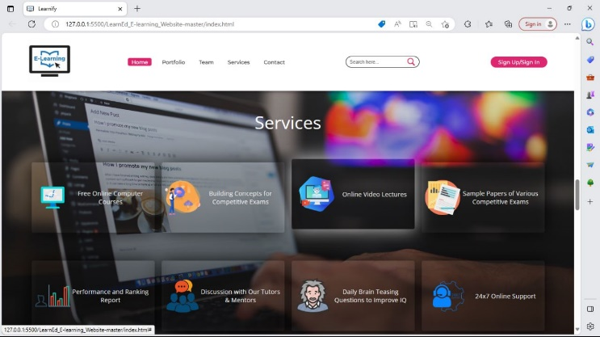

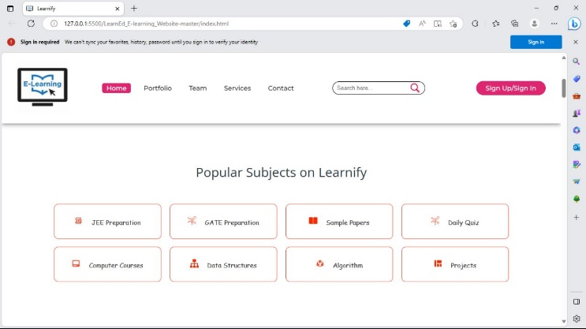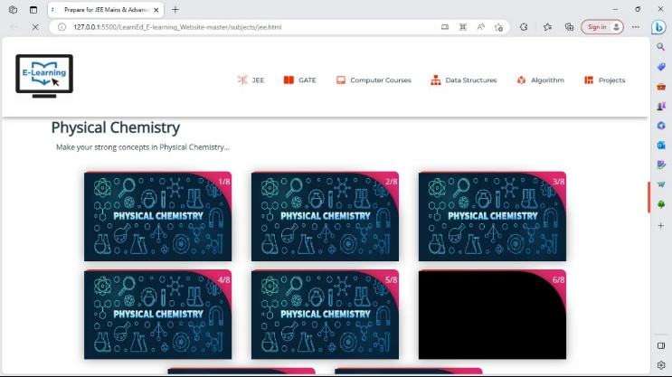

# RESULTS

The result of effective design and development in e-learning is a high-quality online learning experience that promotes learner engagement, knowledge acquisition, and skill development. Well-designed courses incorporate instructional strategies that cater to diverse learning styles and engage learners through interactive activities, multimedia resources, and real-world applications. Learners are provided with clear learning objectives, organized content, and opportunities for practice and assessment. User-friendly interfaces and intuitive navigation enhance the usability of the e-learning platform, allowing learners to easily access and navigate through the course materials. Technical implementation ensures seamless functionality, compatibility across devices, and efficient data management. Assessments provide valuable feedback to learners, enabling them to monitor their progress and identify areas for improvement. Ultimately, effective design and development result in learners achieving the desired learning outcomes, acquiring new knowledge and skills, and gaining confidence in their abilities. The result is a positive impact on learner motivation, engagement, and overall satisfaction with the e-learning experience.

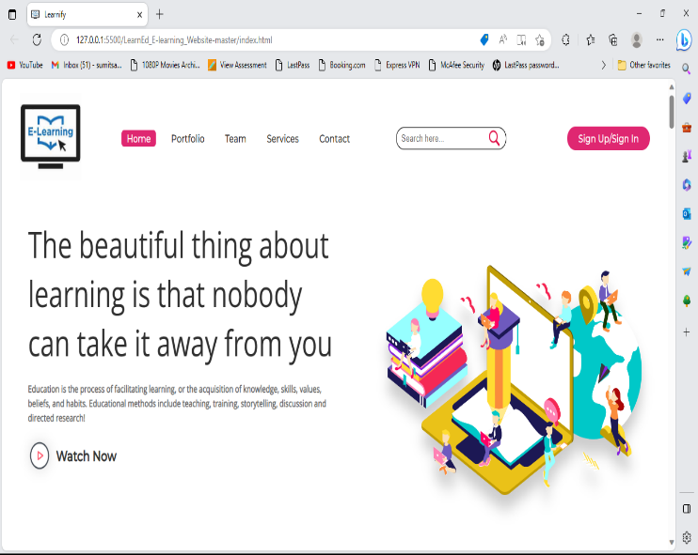

# CONCLUSIONS

In conclusion, e-learning has emerged as a valuable and flexible approach to education, providing learners with accessible, engaging, and personalized learning experiences. The successful implementation of e-learning relies on the effective design and development of online courses and learning materials. The design and development process encompasses various stages, including needs analysis, instructional design, multimedia development, user interface design, and technical implementation. By incorporating instructional design principles, such as learner-centeredness, clear learning objectives, and interactive activities, e-learning courses can promote active engagement and knowledge acquisition. The integration of multimedia elements, such as videos, simulations, and quizzes, enhances learner understanding and retention. A user-friendly interface and intuitive navigation are essential for creating a positive user experience. Attention to accessibility ensures that learners with disabilities can fully participate in the e-learning environment. Technical implementation considerations, including the selection of a suitable learning management system and compatibility across devices, contribute to seamless functionality and user satisfaction. The result of effective design and development in e-learning is a high-quality online learning experience. Learners benefit from enhanced engagement, personalized learning paths, and the acquisition of new knowledge and skills. Assessments and feedback mechanisms enable learners to monitor their progress and identify areas for improvement. Ultimately, successful e-learning design and development foster learner motivation, satisfaction, and achievement of desired learning outcomes. However, it is important to continuously evaluate and refine e-learning courses to ensure their relevance and effectiveness. Regular updates and improvements based on learner feedback and emerging technologies are essential for keeping pace with evolving educational needs and advancements in the field. In conclusion, effective design and development in e-learning contribute to the transformation of education, providing learners with opportunities for growth, skill development, and lifelong learning. By harnessing the potential of technology and applying sound pedagogical principles, e-learning opens up new horizons for accessible, engaging, and impactful education.

##### Acknowledgment

This paper has been validated through experiments. We thank our team members who provided insight and expertise that greatly assisted this paper. We thank Mrs ~Meena Pundir for assistance and comments that greatly improved the manuscript.

##### References

[1] A. Gunasekaran, R. D. Mcneil, and D. Shaul, “E-learning: Research and applications,” *Industrial and Commercial Training*, vol. 34, no. 2, pp. 44–53, Apr. 2002, doi: 10.1108/00197850210417528.

[2] S. V. Thakker, J. Parab, and S. Kaisare, “Systematic research of e-learning platforms for solving challenges faced by Indian engineering students,” *Asian Association of Open Universities Journal*, vol. 16, no. 1, pp. 1–19, May 2021, doi: 10.1108/AAOUJ-09-2020-0078.

[3] A. G. Picciano, “Theories and frameworks for online education: Seeking an integrated model,” *Online Learning Journal*, vol. 21, no. 3. The Online Learning Consortium, pp. 166–190, 2017. doi: 10.24059/olj.v21i3.1225.

.